autoFISH: fluidics system

This document describes how to build a computer-controlled fluidics system.

Overview 2

Building the system 3

Recommended installation workflow 3

Tubing 3

Used connectors 3

Typical connections 3

Components of the fluidics system 4

Buffer storage 1: liquid handling robot 4

Needle holder 4

96 well plate holder 5

Construction and testing of robot 5

Buffer storage 2: syringe holder 5

Automated valve 6

Input/output valve 6

Hamilton MVP/4 valve 6

Peristaltic Pump 7

Bubble trap with vacuum pump 7

Flow sensor 8

Imaging chambers 9

BIOPTECHS FCS2 9

Ibidi multi-channel slides 9

TTL trigger with Arduino 10

Building the Arduino 10

Testing the Arduino 10

Component list 12

Serial port control 13

Find COM for connected component 13

Test already defined component 13

Serial command testing for new components 13

# Overview

This custom build fluidics system is based on a published paper for merFISH and ORCA (Moffit JR et al., 2016) but with some modified components as specified below. They main changes are

* **Bubble trap** to remove air bubbles
* **Flow sensor** to measured pumped volume after each step, and stop system in case a problem occurred
* **Pump placement** in the middle of the fluidics circuit. While it pulls liquid out of the different reservoirs, it pushes liquid through both the bubble trap and the imaging chamber. We found that this has several advantages:
  + Reduces air in the system
  + Permits to use the bubble trap efficiently
  + Reduces movement of the coverslip when pump is activated → reduced risk to loss focus
* Combined uses of **computer controlled valve** and **plate robot**: syringes for general purpose buffers, 96 well plate for round-specific buffers.

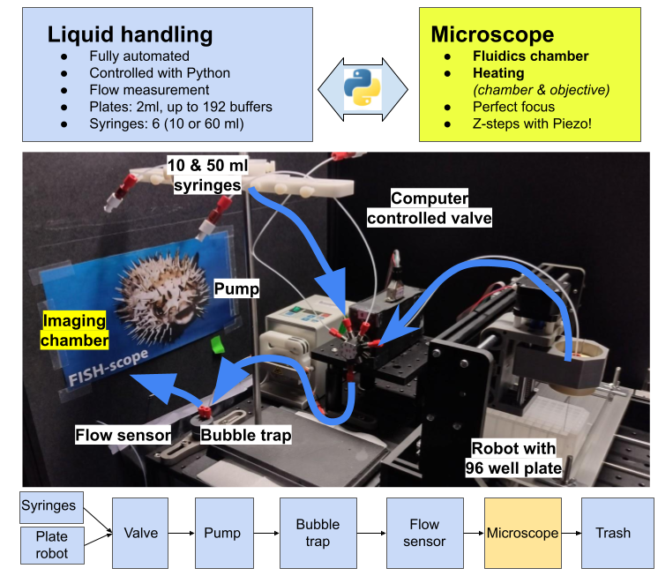

# Building the system

## Recommended installation workflow

1. Install **control software autoFISH** (<https://github.com/fish-quant/autofish>).
2. Make sure that **all required components can be controlled from Python** (we provide dedicated test scripts). For new components, a new Python class has to be added.
3. Perform a **test fluidics runs** without liquid and tubing to make sure communication is working and you get familiar with the control software.
4. Once all components are controlled, start **adding the fluidics connections**

## Tubing

We use either **TEFZEL/ETFE** or **PTFE** tubing with a small inner diameter (ID =0.5mm = 0.020") to minimize the amount of required liquid. The other diameter (OD) of 1/16" is standard for many fluidics applications.

## Used connectors

|  |  |  |  |
| --- | --- | --- | --- |
| P-658 | 1/4-28 Female to  Female Luer | Connects on syringe (male Luer) and connects to XP-202 |  |
| XP-202 | Flangeless Fitting Delrin,   * 1/4-28 Flat-Bottom * For 1/16" OD | Connect tubing to a threaded ¼-28 Port. |  |
| P-655 | Luer Adapter Assembly  1/4-28 Female to Male Luer | Connects to output of valve (female Luer) allows attachment of XP-202 |  |
| P-646 | Barbed to Threaded Male for soft 1/16" ID tubing, ¼ -28 male | To connect soft tubing (imaging chamber) |  |
| P-603 | Standard Union Delrin, ¼-28 Port | Screws on IDEX P-646 and allows connection of XP-202 |  |
| P-692 | Conical adaptor for soft tubing, ¼-28 male. | To connect soft tubing (vacuum pump) |  |

## Typical connections

Several connectors are used to connect the tubing to the different components. Connections are **shown in blue**, we also provide pictures to show how these should be assembled. The two main connection types are:

* Most connections rely on a standard **¼-28 Threaded Connection**, where you use nut (blue) and a threaded connector (red) to connect the tube with another connector

|  |
| --- |
|  |

* Other connections are based on **male or female Luer locks** (commonly found on syringes). Show below is how such a Luer connector can be used in combination with a threaded connection to connect the fluidics tubing to a syringe.

|  |  |
| --- | --- |
|  |  |

# Components of the fluidics system

Here, we describe how to build the system starting from the buffer storage to the flow-sensor. For a complete list of all required components, please consult the dedicated section ***Component list***.

## Buffer storage 1: liquid handling robot

We used a 3D CNC robot, where we replaced the CNC router with a custom printed syringe holder. We also used a Plexiglas with 2D cutouts for two 96 well plates.

|  |  |
| --- | --- |
| * **Model**: CNC 3018 Pro * **Important**: has to be controlled by **GRBL** * **Hamilton needle** * **Connection**: **IDEX P-655 and P-202**   **Note: we glued the connectors together**, since they can wiggle free when the robot moves a lot. |  |

### Needle holder

|  |  |
| --- | --- |
| We 3d printed a needle holder that fits in the spindle holder. This is essentially a cylinder with a central hole to accommodate the needle.  We further added a headless screw that can be used to secure the needle firmly. |  |

### 96 well plate holder

|  |  |
| --- | --- |
| To securely place the 96 well plates on the robot (example below for a 3018 with plate dimension of 30x18cm), we use a holder made of sturdy cardboard or Plexiglass. |  |

### Construction and testing of robot

1. Build according to instructions. Once build, you should already be able to move the robot with the provided joystick.
2. Install provided driver (for our robot it was named CH340SER.exe)
3. Connect USB to computer.
4. Determine your Machine's COM port (see below).
5. Open provided control software (for our robot grblControl)
6. Attempt to move the robot from within the software.
7. If this works, you should be able to use the robot in our Python control software.

## Buffer storage 2: syringe holder

|  |  |
| --- | --- |
| For general purpose buffers, e.g. for washing or imaging, we use syringes (from 10ml to 140 ml) with a female Luer lock. We use a modular syringe Holder from Warner instruments permitting to assemble a syringe holder accepting different volumes, as well as the corresponding Support Stand (**W3 64-0162**).  **Connection**: **P-658 and XP-202** |  |

|  |  |
| --- | --- |
| When the system is not used, we wash all fluidic lines with water and remove the syringes. We close the connectors (P-658) with a lid (the ones shown on the right come from a purification kit and are used to close purification columns). |  |

## Automated valve

We use computer-controlled valves with several inputs (8 for the one listed below) and one output. Several companies produce such valves, we use the ones of **Hamilton** or **AMF**.

|  |  |
| --- | --- |
| Shown on the right is the valve itself with 4 connected inputs (ports 4 to 7) and one output.  Inputs are connected with threaded connections, output is connected with a female Luer.   * **Entry**: **Idex XP-202** * **Exit (Hamilton)**: **Idex P-655 + XP-202** |  |

### Input/output valve

Certain valves permit flow in both directions. Then can thus either be used to select from several incoming fluidical lines, e.g., to select from different buffers, or to select for different output lines, e.g. to direct buffer to a specific sample. We use the latter when working with Ibidi multi-channel slides. Our control software autoFISH supports both input and outlet valves.

### Hamilton MVP/4 valve

For Hamilton, the valve positioner as well as the valve itself is required. The valve positioner is delivered with a power supply and control cable.

|  |  |
| --- | --- |
| **Address switch** The Address Switch is set such that the first MVP/4 is set to “0,” second to “1,” and so forth. |  |

**DIP and termination switches**

You have to change the

* **DIP switches** (4-6) to indicatethatthe used valve has 8 ports (Table 2-2, page 14).
* Termination switch (7-8) have to be set to indicate that we only have one valve.

|  |  |  |  |  |  |
| --- | --- | --- | --- | --- | --- |
| SWITCH | **4** | **5** | **6** | **7** | **8** |
|  | ON | ON | OFF | ON | OFF |

## Peristaltic Pump

We currently support different options **Ismatec REGLO DIGITAL** or **Longer BT100**.

|  |  |
| --- | --- |
| * Needs to be controllable via the serial port. * **Entry & exit**: **Blunt Gauge 25 needles (OD 0.54mm) with Luer Lock. +** **P-655 + XP-202** |  |

## Bubble trap with vacuum pump

We use a **bubble trap** to remove air bubbles from the buffers (especially EC is degassing). The bubble trap can be connected to a **vacuum pump** which will help to increase bubble removal. We use a small piezo pump, the pump itself is very cheap, the controller is comparatively expensive, but it is very convenient. The starter set listed in the components section contains the vacuum pump, controller and soft wall tubing.

|  |  |
| --- | --- |
| Shown on the left is the bubble trap with the entry/exit of the fluidics on the top, and the vacuum line connected at the bottom.   * + **Target flow rate:** 4 ml / min (sine signal, 250V, 50 HZ) More settings see below.   + **Connection of fluidics**: **XP-202**   + **Connection of vacuum line: P-692 + soft tubing** |  |

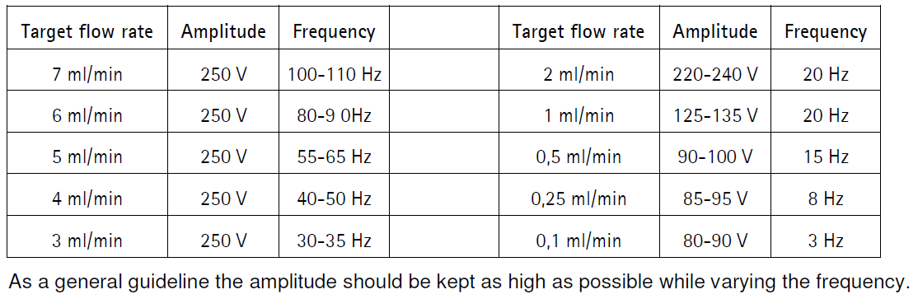

## Flow sensor

|  |  |
| --- | --- |
| We use a flow sensor from Sensirion. The proposed evaluation kit comes with a USB cable that permits measuring flow with a **provided viewer software (USB/RS485).** Measured flow can be saved in a csv file, which can be read by the Python control software.   * **Entry and exit**: **XP-202** |  |

## Imaging chambers

### BIOPTECHS FCS2

|  |  |
| --- | --- |
| We use the Bioptechs FCS2 flow chamber for imaging of tissue samples. We recommend purchasing the starter set, which also contains the temperature control and several silicon gaskets.  Show on the left is the mounted chamber, with the fluidics entry on the right, exit on the left. Temperature control is connected on the top./ |  |

* **Entry: soft tubing** + **IDEX P-646 + IDEX P-603 + XP-202**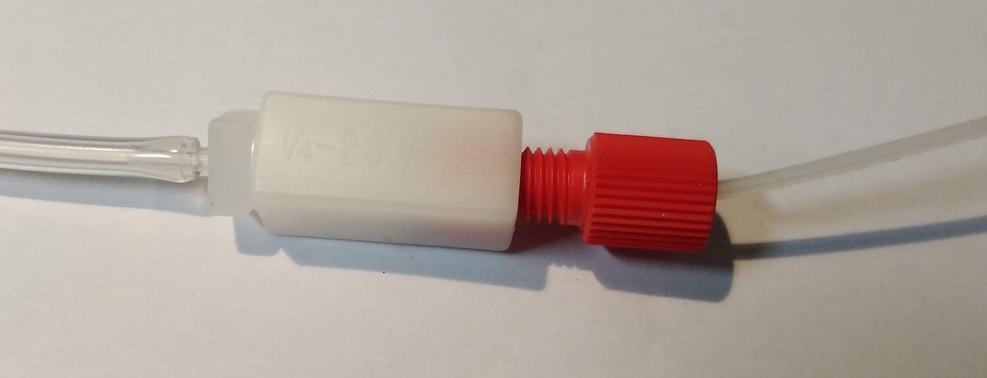
* **Exit:** we use only the soft tubing without any connectors to avoid clocking up, when parts of the samples dislodge.

### Ibidi multi-channel slides

The advantage of these multi-channel slides is that multiple conditions can be tested in parallel, e.g. WT vs drug treatment. They can be connected with a female adaptor sold by Ibidi connected to softwall tubing.

#### ADD PICTURES

A **few important considerations**

* We found it difficult to obtain consistent flow rates in each channel when using a manifold to distribute liquid. We therefore use an **automated outlet valve** to flow liquid subsequently through each channel. This leads to an only marginal increase of experimental duration, since flow duration is longest only for the first channel where the entire system is filled, for subsequent channels a shorter duration is required since only the liquid between the valve and the channel must be replaced.
* To **avoid air bubbles** when connecting the Luer locks to the channel slide, we recommend filling the slide completely and gently pressing the Luer lock inside to displace the extra liquid.
* For temperature control, we use the chamber slides in small top stage incubator, e.g. from Okolab.
* Imaging multiple channels means **moving the objective over larger distances**. This can be problematic with respect to loss of focus and immersion medium.
  + Ideally the system is equipped with an autofocus.
  + High NA water objectives with an automated water dispenser can help to maintain immersion medium, otherwise generously covering the underneath of the channel slide with oil can also help.

## TTL trigger with Arduino

In our control software, we provide the option to communicate with a microscope via TTL pulses.

1. A pulse (TTL OUT) is sent to indicate that an acquisition should be launched.
2. The system waits for an incoming TTL pulse indicating that the acquisition is terminated.

For this, we provide a code segment for an Arduino (see dedicated documentation and GitHub). The Arduino is easy to build and can be tested with a provided Python code.

### Building the Arduino

Instructions are provided for an Arduino UNO R3. Other options might work as well but were not tested.

Upload the software to your Arduino. Different options exists, see the official Arduino website: <https://docs.arduino.cc/learn/starting-guide/getting-started-arduino/>

Two TLL lines are required, as an end connector we use BMC (male or female depending on the needs)

* **TTL OUT**: + connected to pin 12, - to GND
* **TTL IN**: + connected to pin10, - to GND

### Testing the Arduino

Two different pins are enabled in the provided code: pin 7 is HIGH, pin 8 is LOW. These pins allow to simulate the incoming TTL signal to indicate that the acquisition is done.

|  |  |
| --- | --- |
|  |  |
| Connection of TLL out to a LED for testing. | Connection of TLL in to the pin 7/8 for testing |

To test

1. Connect the TTLs
   1. TTL OUT to a small test circuit with an LED (e.g. as described here <https://docs.arduino.cc/built-in-examples/basics/Blink/> )
   2. TTL IN: - to the GND, + to pin 8
2. Find COM port where Arduino is connected.
3. Launch Python code (arduino_TTL_synchronization.py)
   1. Update port in serial connection (arduino = serial.Serial …)
   2. Launch the While loop.
   3. You will be asked for an input, ‘start’ will send the TTL OUT, and the LED should turn on and remain on.
   4. To indicate the acquisition is done, set the TTL in to HIGH (by moving to pin 7). The LED should turn off.

# Component list

Note: we listed the minimum number of IDEX connectors you will need, ordering a few extra for security might be good.

|  |  |  |
| --- | --- | --- |
| **What** | **References** | **Quantity** |
| Peristaltic pump | Ismatec REGLO DIGITAL or Longer BT100 plus adequate tubing | 1 |
| Tubing (fluidics) | Tube TEFZEL/ETFE 1/16" (OD) x 0.50mm (ID) | 5m |
| Clear PVC tubing | McMasterCarr 5233K51. ID1/16“ ID To connect the imaging chamber | 1m |
| Tubing to threaded port | IDEX XP-202 | 20 |
| Syringe adapter | IDEX P-658 | 1 per syringe, 1 for Hamilton valve |
| Male Luer | IDEX P-655 | 2 |
| Barbed to threaded Male | IDEX P-646 | 1 |
| Standard Union for threaded ports | IDEX P-603 | 1 |
| Conical to threaded male | IDEX P-692 | 1 |
|  | LIDS for closing when done |  |
| Syringe holder | Warner Instruments : stand, base unit, additional units | 1 |
| Robot | CNC 3018 Pro, important to have GRBL support | 1 |
| Needles | Hamilton™ 90523 (Kel F Hub Needles) Ga25 (ID 0.26mm), needle style 3 (blunt), 51mm | 1 (sold by 6) |
| Imaging chamber | BIOPTECHS FCS2 Starter set | 1 |
| Valve positioner | [Hamilton MVP/4 Valve Positioner](http://www.hamiltoncompany.com/search/search_results/MVP4-Valve-Positioner) | 1 |
| Valve | [Hamilton CERAMIC, HVCX, 8-5](http://www.hamiltoncompany.com/search/search_results/VALVE-CERAMIC-HVCX-85-PSD4) | 1 |
| Flow sensor | Sensirion Flow Sensor evaluation kit SLF3S-0600 | 1 |
| Bubble trap | ELVEFLOW Autoclavable Bubble Trap for Microfluidics | 1 |
| Vacuum pump + control | [Bartels mp-Lab! Evaluation Set](https://darwin-microfluidics.com/collections/vendors?q=Bartels) | 1 |
| Serial-to-USB adaptor | USB to Straight-Through RS232 Serial Adapter | 2 |

# Serial port control

## Find COM for connected component

To control the different components, you will need to know their **COM port** when connected to a computer. This port usually doesn’t change . To see on which port your components are

1. Right click on the Windows Start Icon and select "Device Manager."
2. Open the "Ports (COM & LPT)" Section.
3. Locate the appropriate Device (if you don’t know which one, disconnect and reconnect it) and note which COM port it is connected to.

## Test already defined component

In autoFISH, we support components from different providers. For each, we have a small Python test code to test them separately.

## Serial command testing for new components

To test the serial commands for a new hardware component, dedicated programs can be used send commands to serial ports.

* **Termite**: simple program to send and receive data to a USB port (<https://www.compuphase.com/software_termite.htm>)
* **Portmon**: a tool to monitor activity on serial ports<https://docs.microsoft.com/en-us/sysinternals/downloads/portmon>
* Some more information for how to **monitor serial port activity**  
  <https://technet.microsoft.com/en-us/sysinternals/bb896644>

Once this works, you can then use our Python control software **autoFISH**, here you will need to write a new class in automator.py integrating the specific commands for your component.